Experiment No. 6

**Aim:**

To draw the sequence diagrams for the University Registration System.

**Description:**

A sequence diagram is an interaction diagram that shows how objects operate with one another and in what order. It is a construct of a message sequence chart.

A sequence diagram shows object interactions arranged in time sequence. It depicts the objects and classes involved in the scenario and the sequence of messages exchanged between the objects needed to carry out the functionality of the scenario. Sequence diagrams are typically associated with use case realizations in the Logical View of the system under development. Sequence diagrams are sometimes called event diagrams or event scenarios.

Steps to be followed

* The classes and actors in a use case are identified for the purpose of construction of sequence/collaboration diagram
* The timeline of the operations is identified and drawn
* Appropriate messages , procedure calls and return messages are sent from one class to the other in accordance with the time frame

**SEQUENCE DIAGRAM**

1. Login
   1. Basic Flow

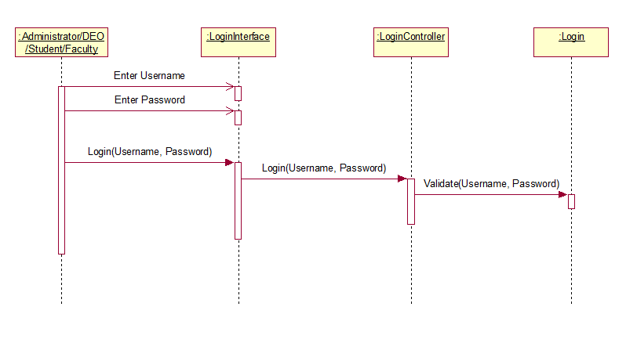

* 1. Alternate Flow

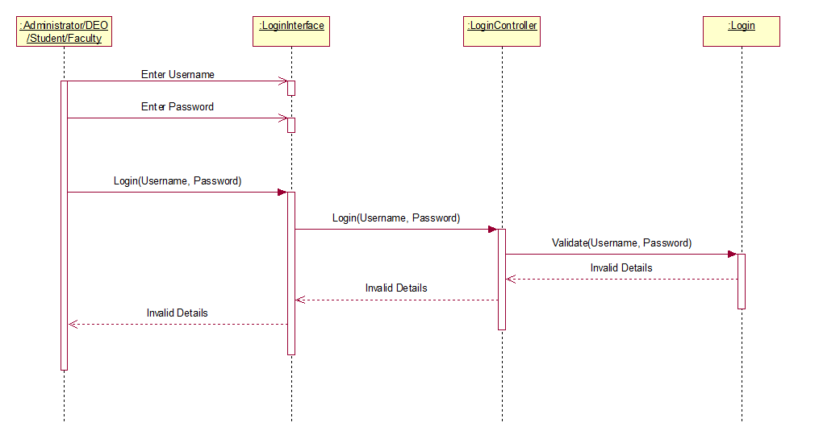

1. Maintain Student Details
   1. Add Student – Basic Flow

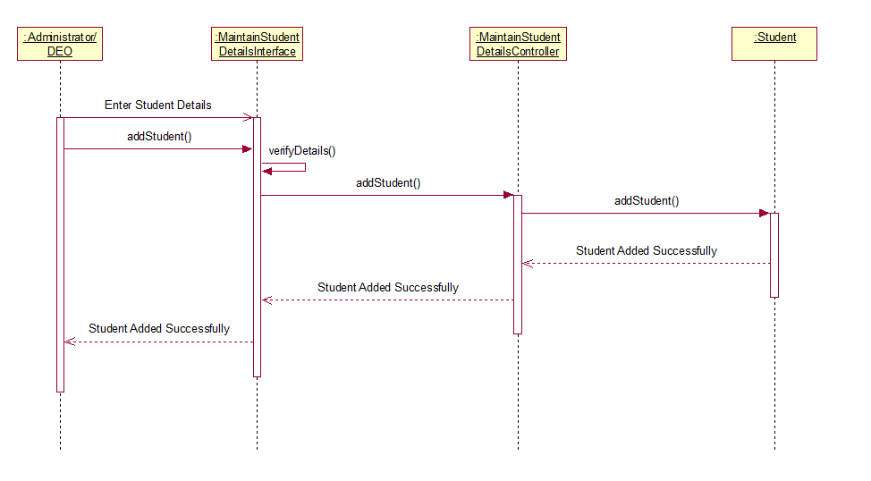

* 1. Add Student – Alternate Flow – Invalid Student Details

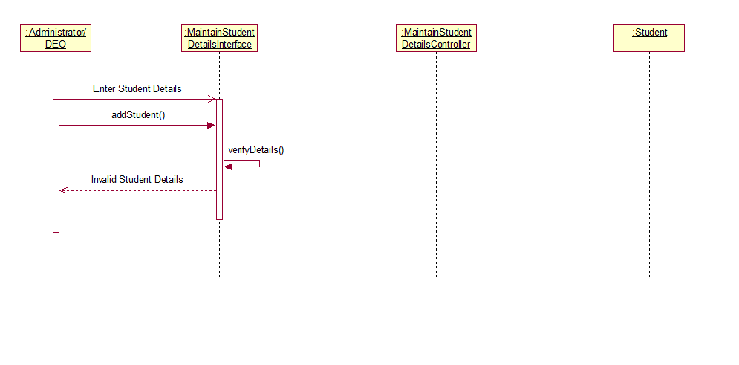

* 1. Add Student – Alternate Flow – Student Already Exists

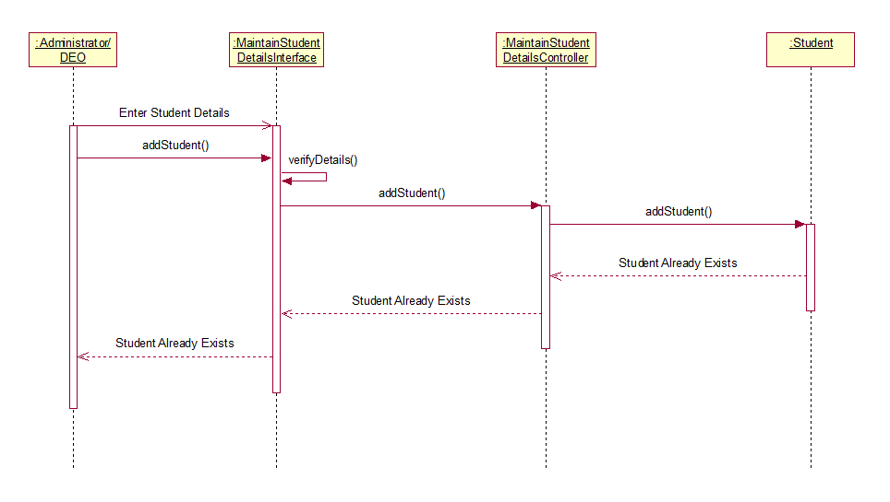

* 1. Delete Student – Basic Flow

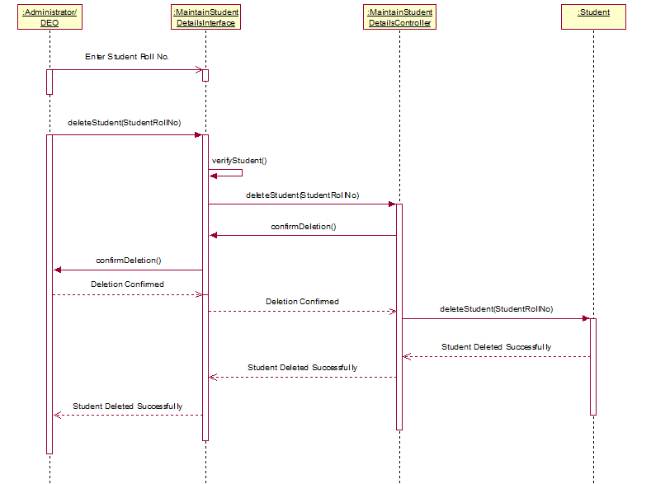

* 1. Delete Student – Alternate Flow – Student Does Not Exist

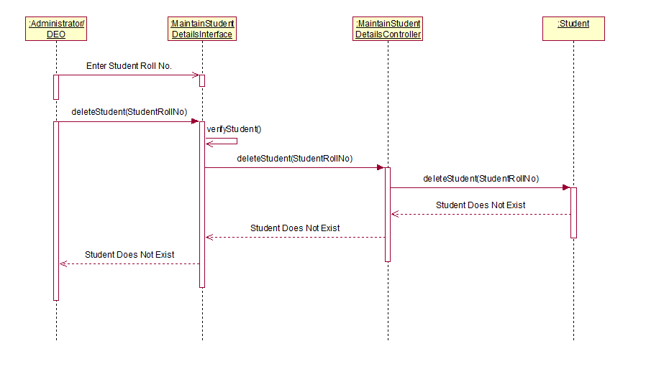

* 1. Delete Student – Alternate Flow – Deletion Cancelled

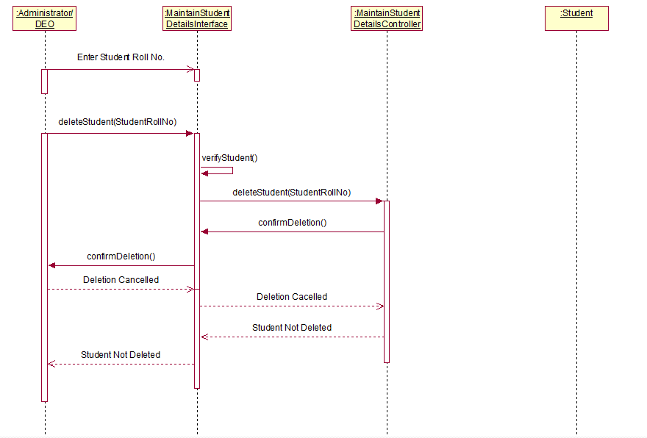

* 1. Update Student – Basic Flow

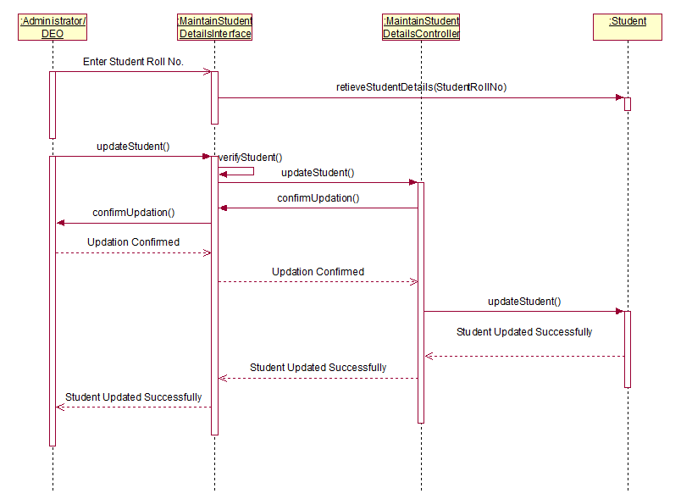

* 1. Update Student – Invalid Student Details

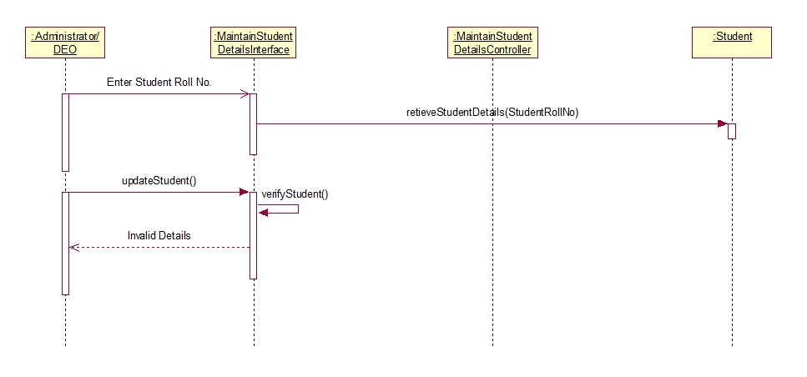

* 1. Update Student – Alternate Flow – Student Does Not Exist

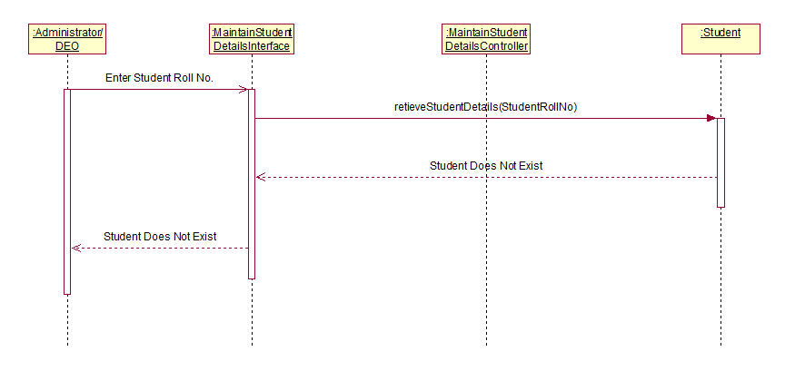

* 1. Update Student – Alternate Flow – Deletion Cancelled

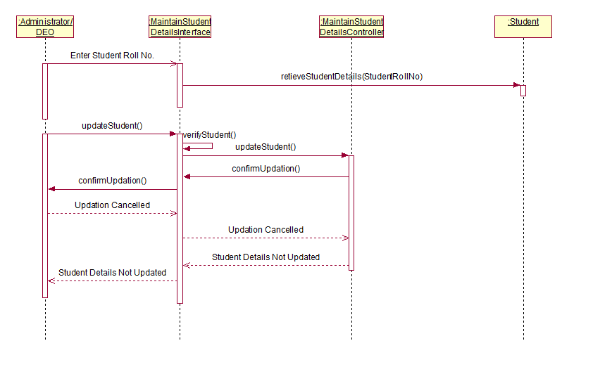

* 1. View Student – Basic Flow

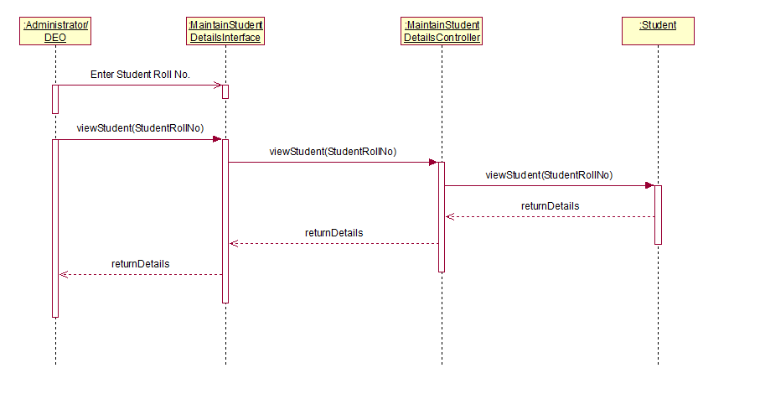

* 1. View Student – Student Does Not Exist

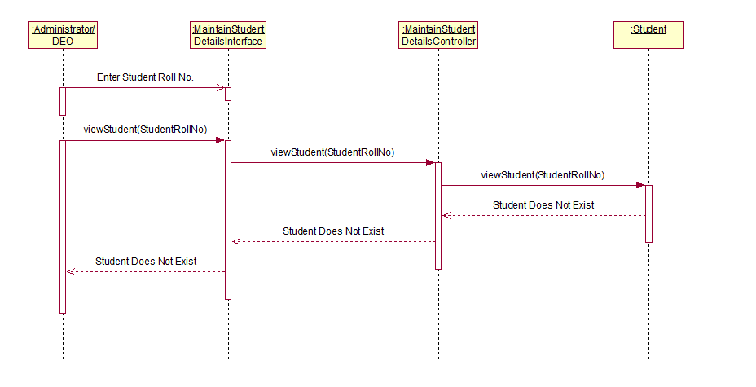

1. Maintain Faculty Details
   1. Add Faculty – Basic Flow

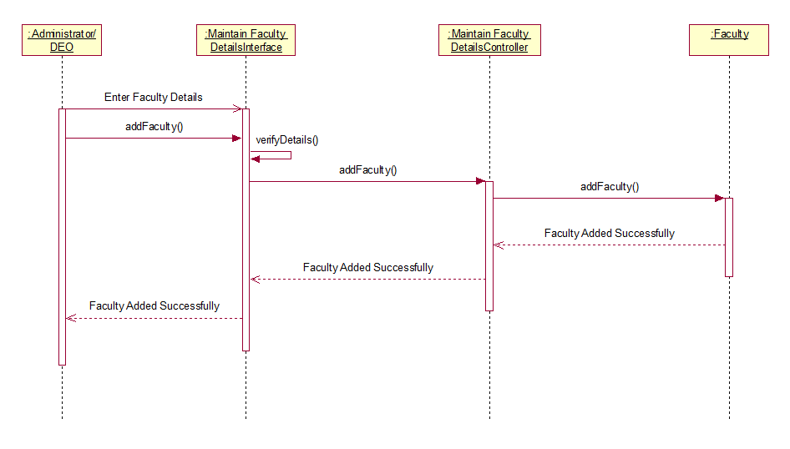

* 1. Add Faculty Alternate Flow – Invalid Faculty Details

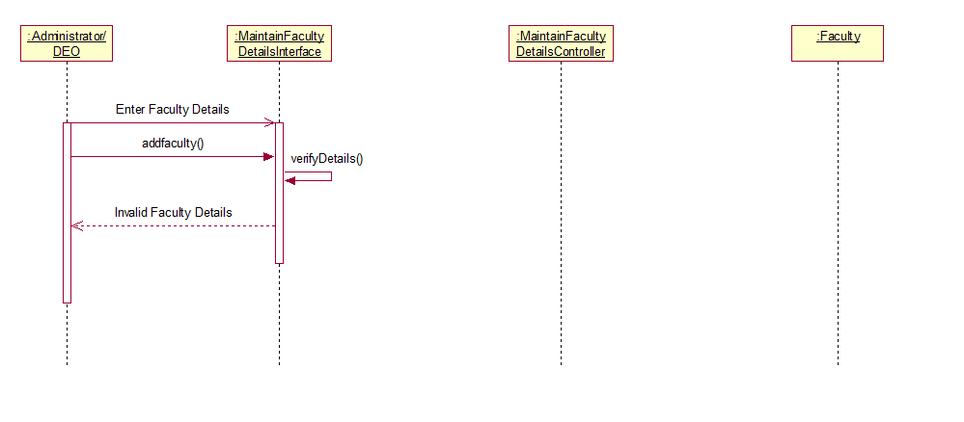

* 1. Add Faculty – Alternate Flow – Faculty Already Exists

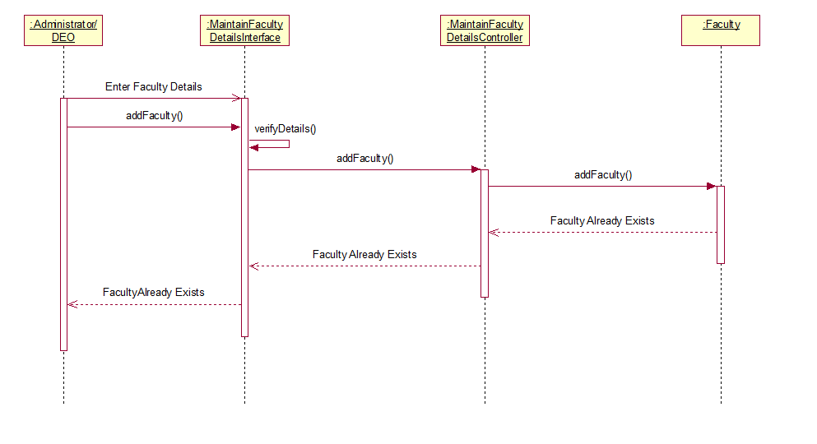

* 1. Delete Faculty – Basic Flow

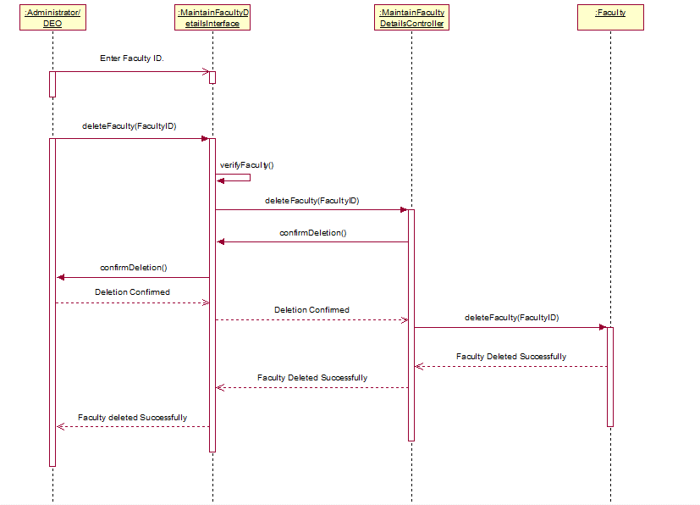

* 1. Delete Faculty – Alternate Flow – Faculty Does Not Exist

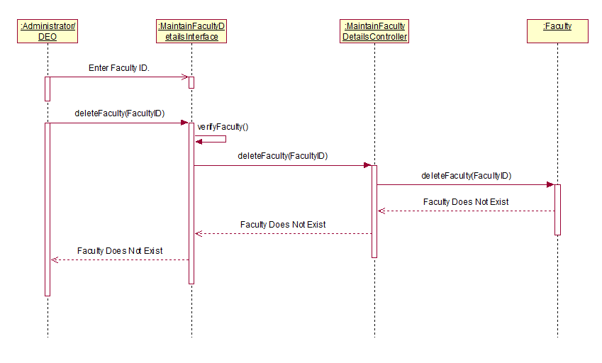

* 1. Delete Faculty – Alternate Flow – Deletion Cancelled

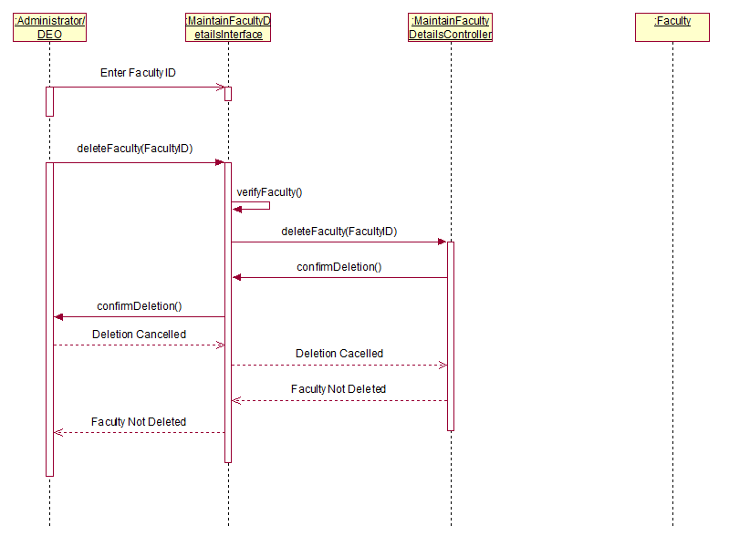

* 1. Update Faculty – Basic Flow

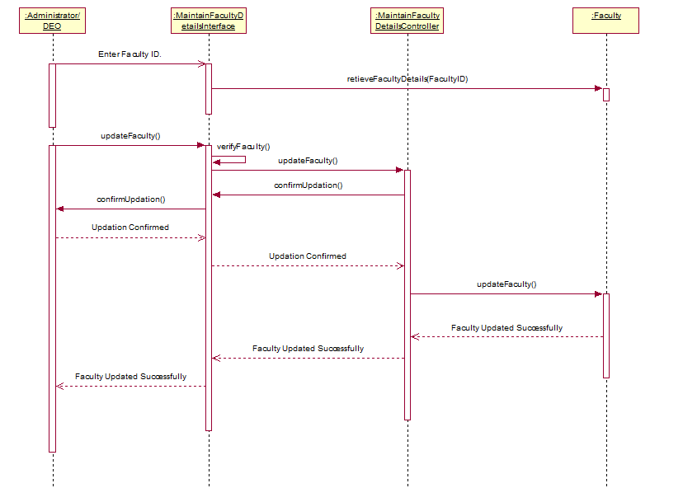

* 1. Update Faculty – Invalid Faculty Details

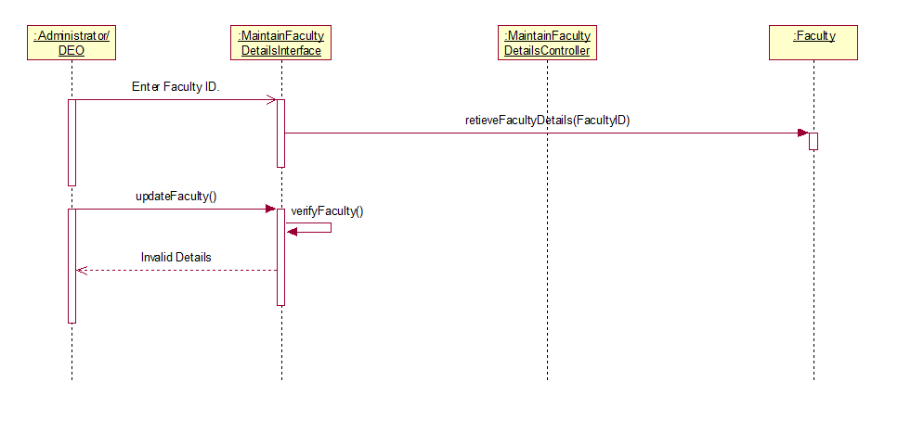

* 1. Update Faculty – Alternate Flow – Faculty Does Not Exist

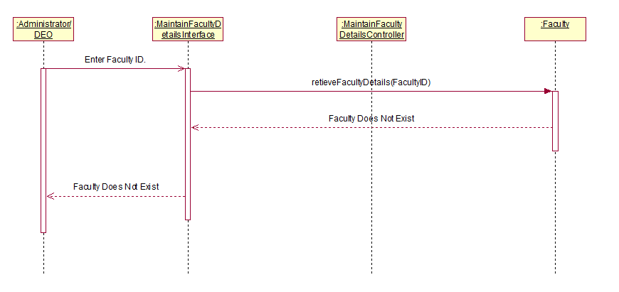

* 1. Update Faculty – Alternate Flow – Deletion Cancelled

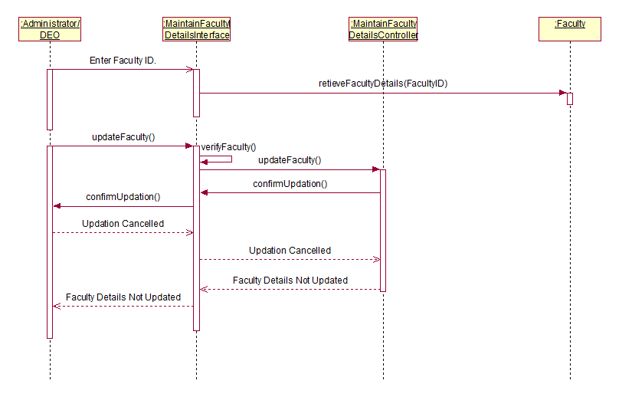

* 1. View Faculty – Basic Flow

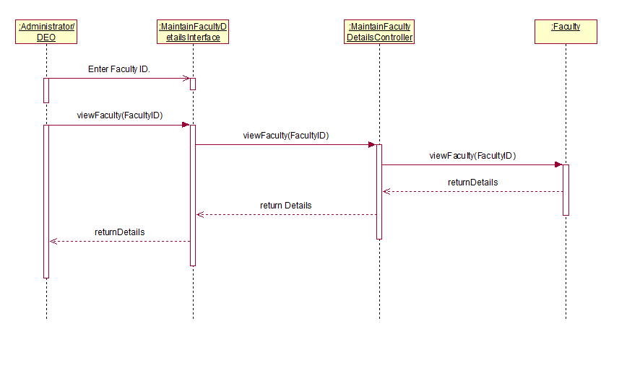

* 1. View Faculty – Faculty Does Not Exist

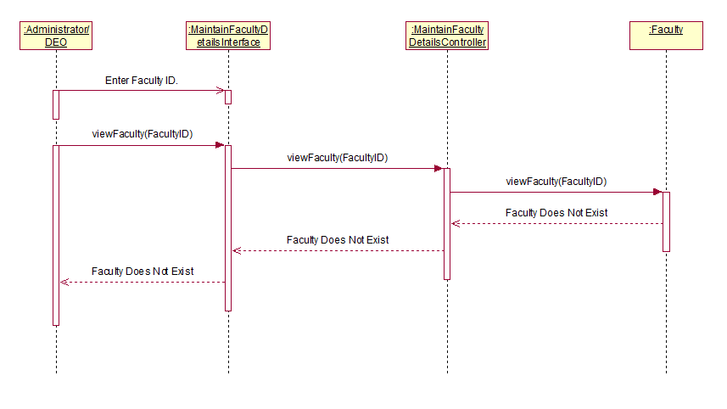

1. Maintain Course Details
   1. Add Course – Basic Flow

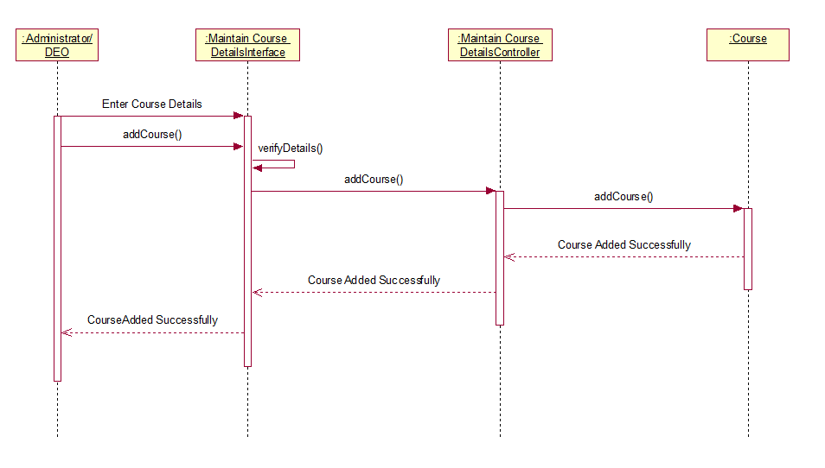

* 1. Add Course Alternate Flow – Invalid Course Details

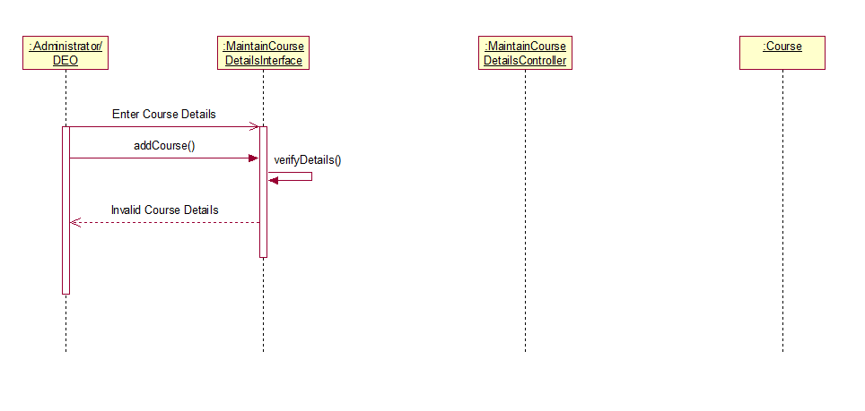

* 1. Add Course – Alternate Flow – Course Already Exists

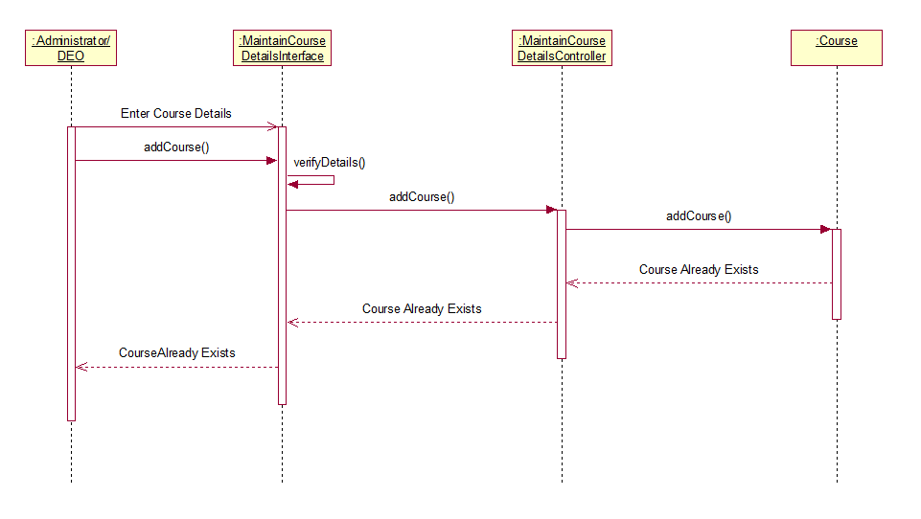

* 1. Delete Course – Basic Flow

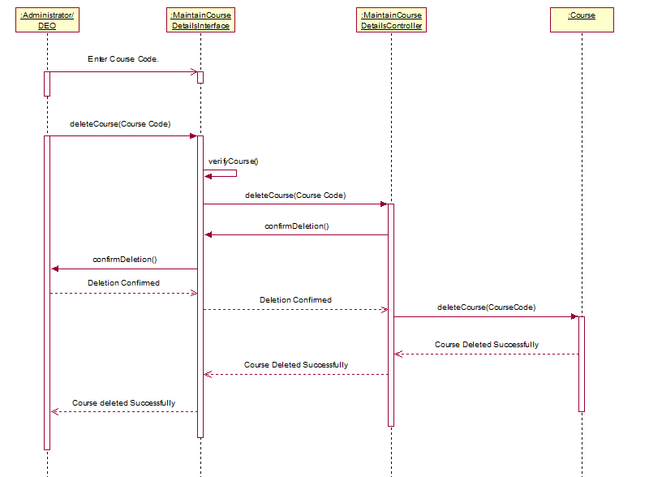

* 1. Delete Course – Alternate Flow – Course Does Not Exist

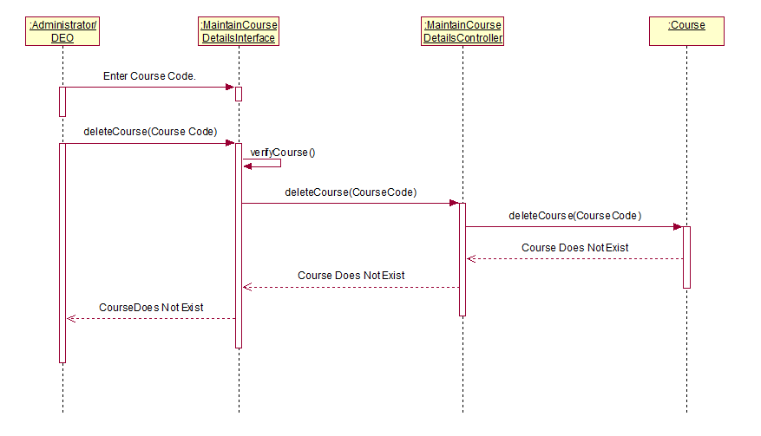

* 1. Delete Course – Alternate Flow – Deletion Cancelled

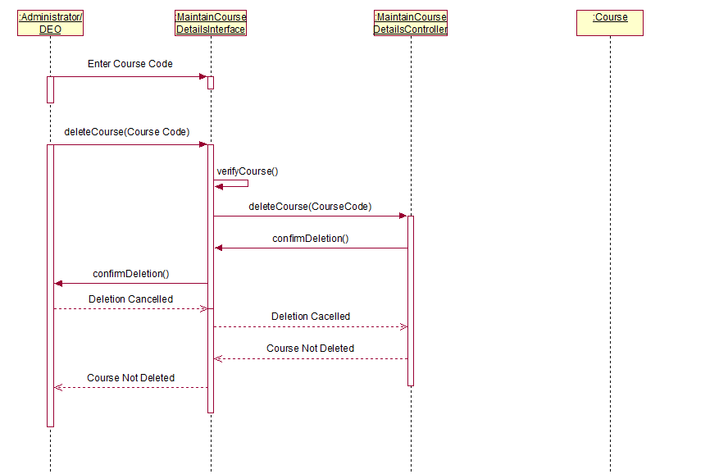

* 1. Update Course – Basic Flow

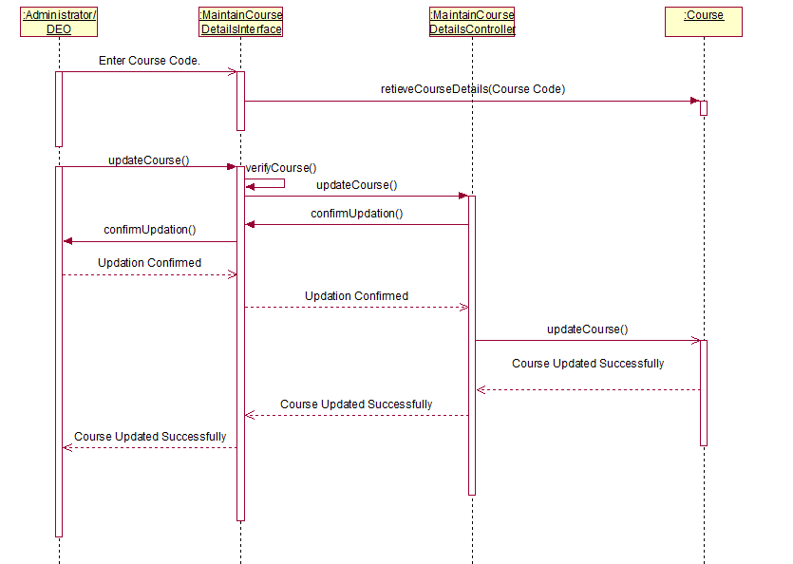

* 1. Update Course – Invalid Course Details

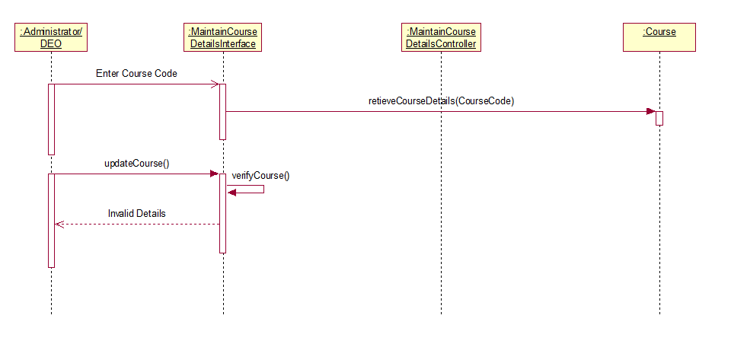

* 1. Update Course – Alternate Flow – Course Does Not Exist

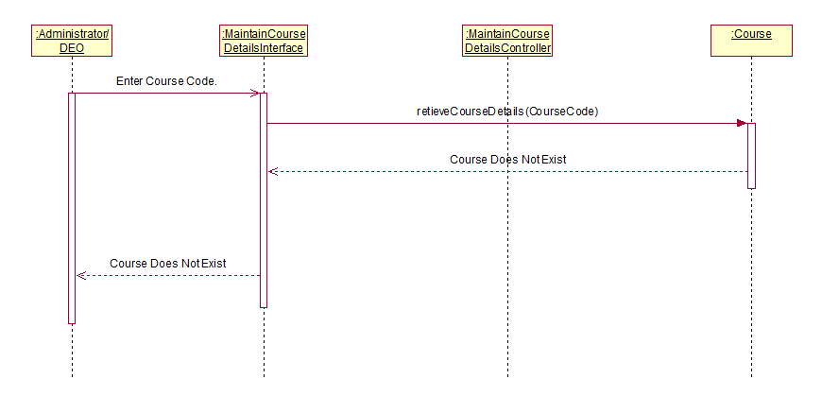

* 1. Update Course – Alternate Flow – Deletion Cancelled

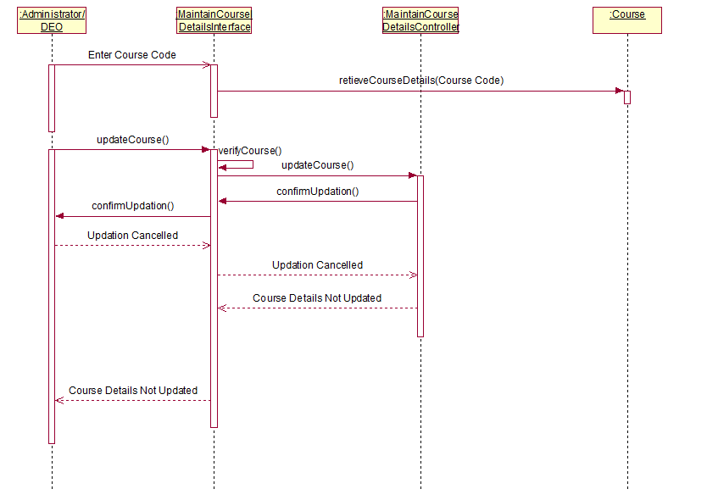

* 1. View Course – Basic Flow

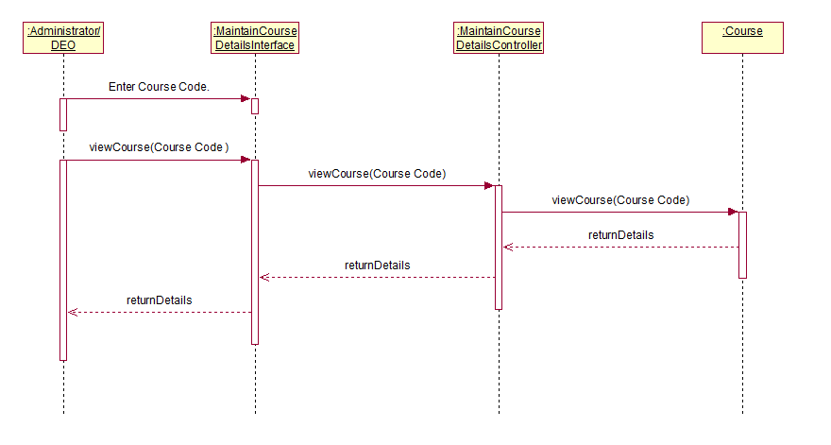

* 1. View Course – Course Does Not Exist

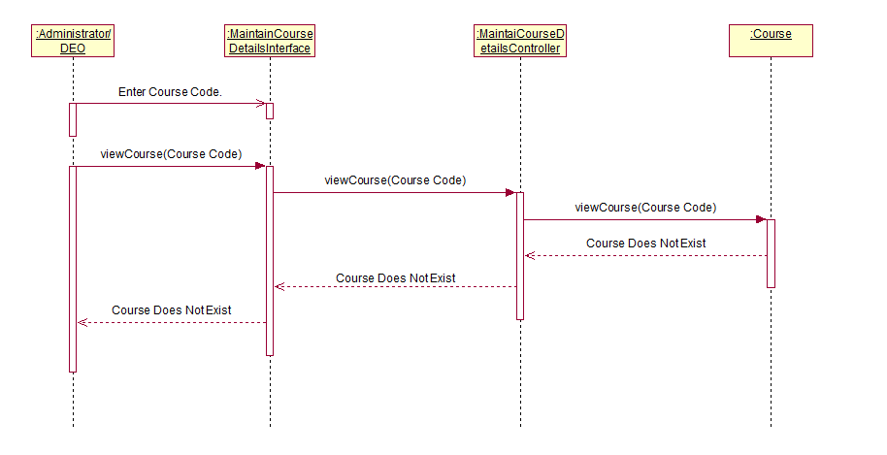

1. Maintain Marks
   1. Add Marks – Basic Flow

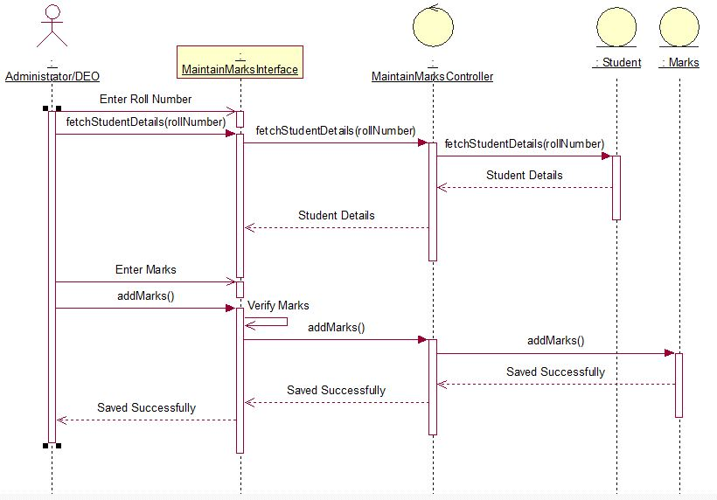

* 1. Update Marks – Basic Flow

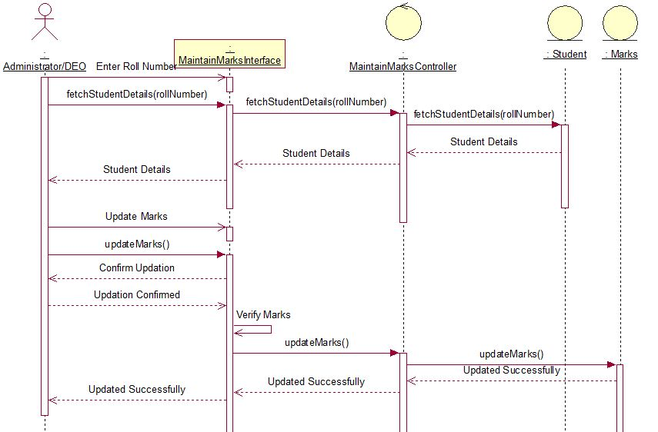

* 1. View Marks – Basic Flow

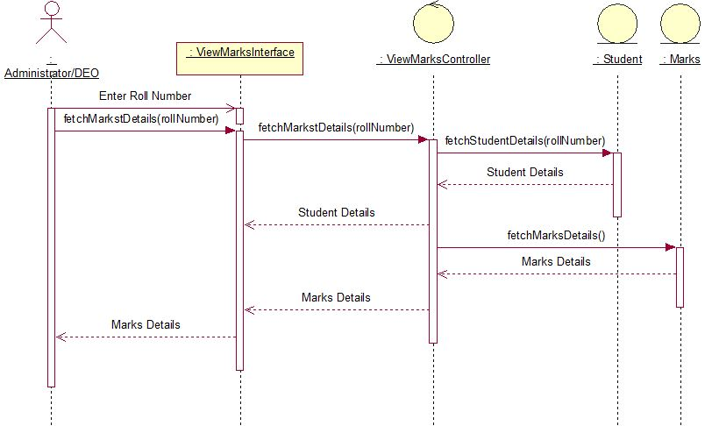

* 1. View Marks – Alternate Flow – Print Marks

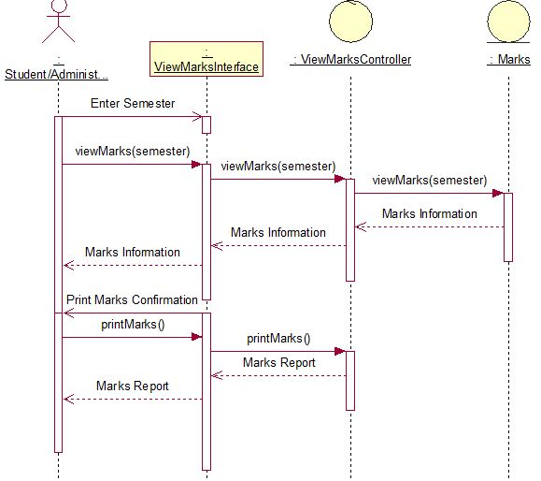

* 1. View Marks – Alternate Flow – User Exit

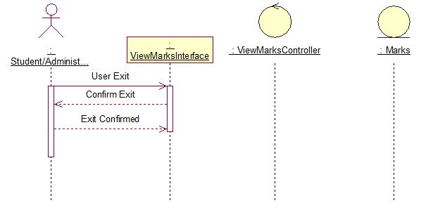

* 1. Add Marks/Update Marks – Alternate Flow – Invalid Details

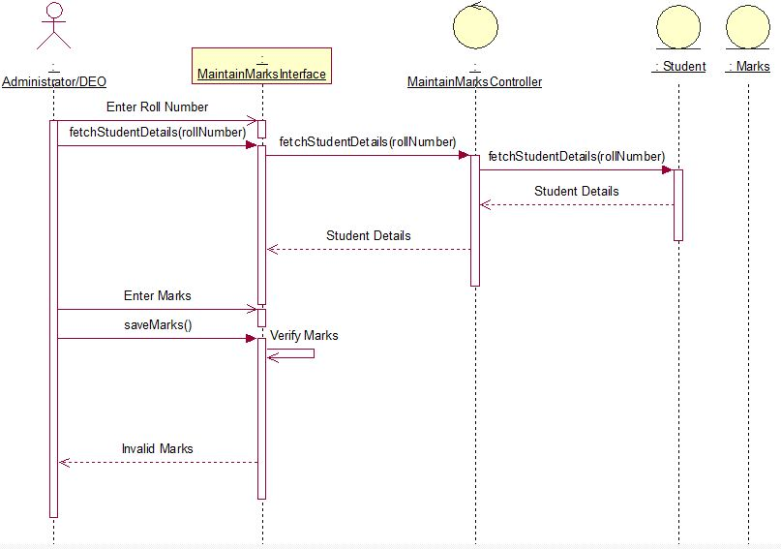

* 1. Add Marks - Alternate Flow - Marks Already Entered

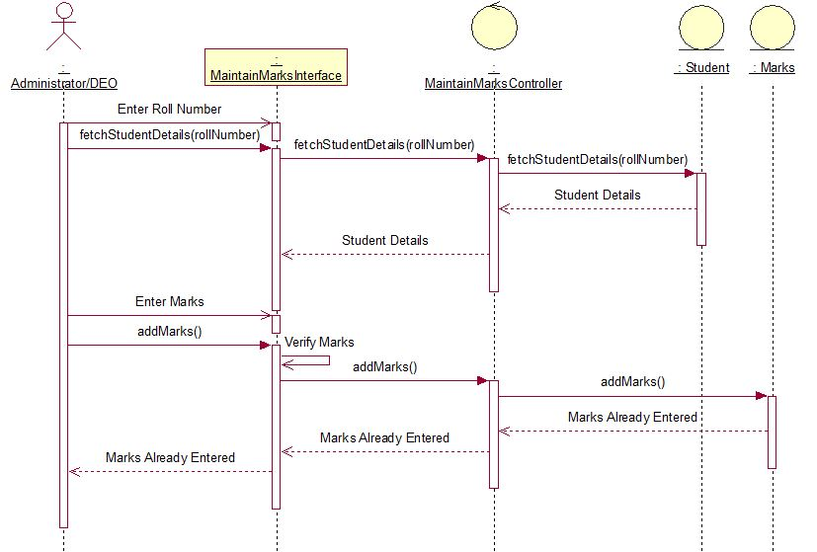

* 1. Add Marks - Alternate Flow – Student Not Found

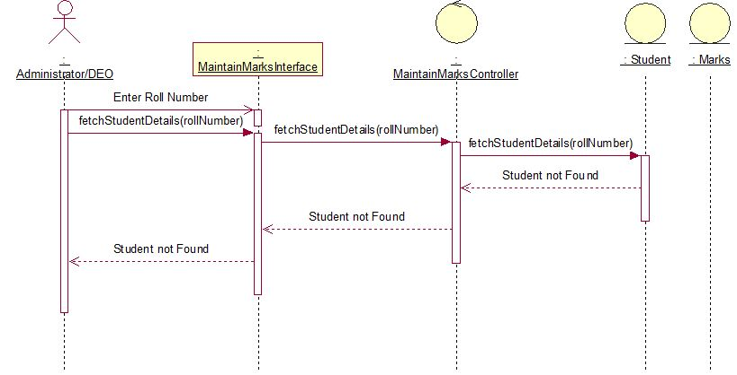

* 1. Add Marks - Alternate Flow – User Exit

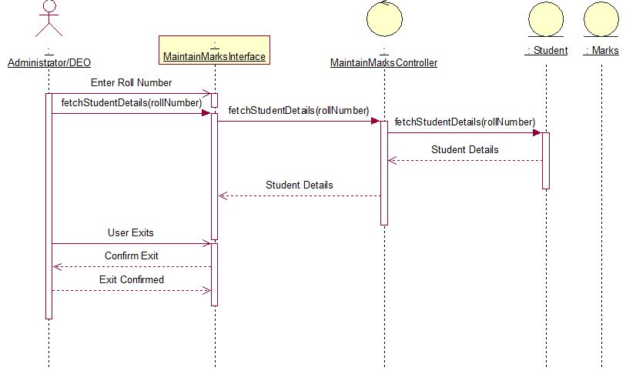

* 1. Update Marks - Alternate Flow – Updation Cancelled

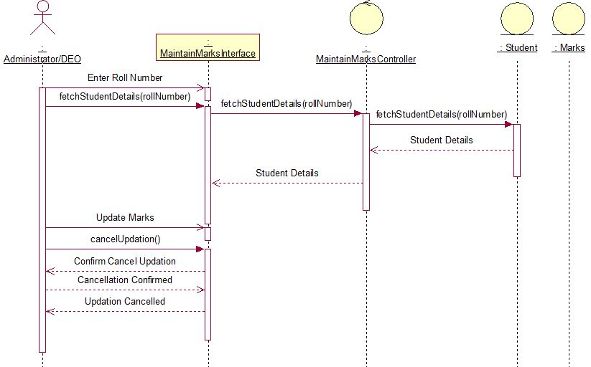

* 1. Print Marks – Alternate Flow – Print Cancelled

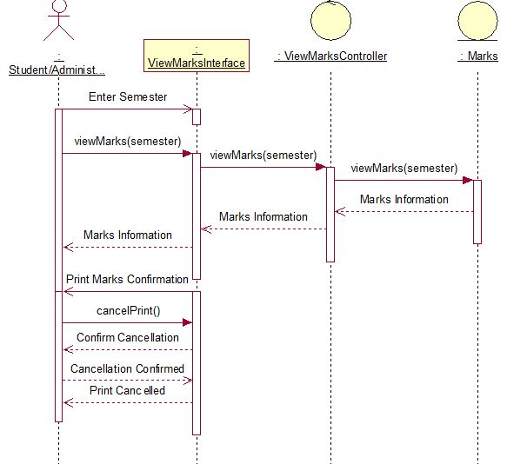

* 1. Maintain Marks – Alternate Flow – Student Not Found

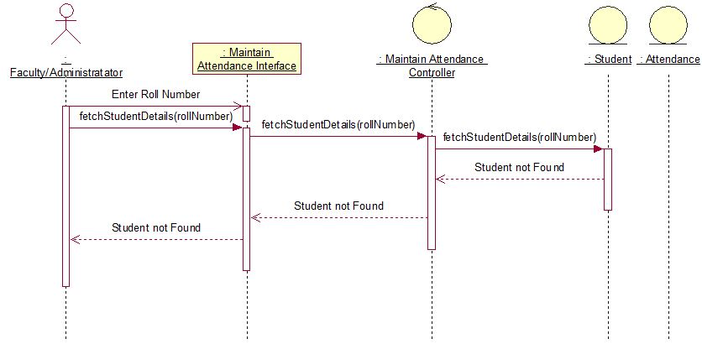

1. Maintain Attendance
   1. Basic Flow

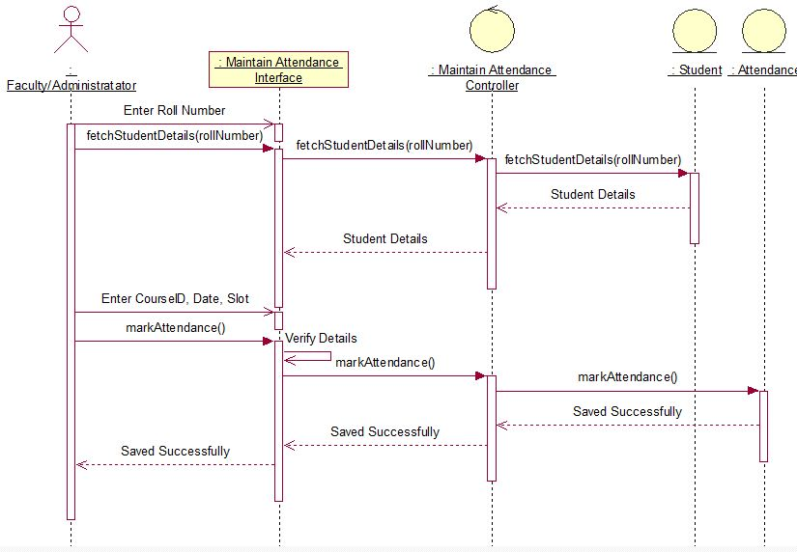

* 1. Maintain Attendance - Alternate Flow - Invalid Details

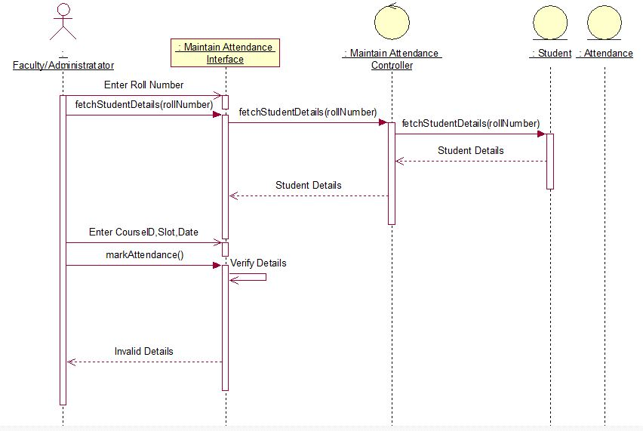

* 1. Maintain Attendance – Alternate Flow – User Exits

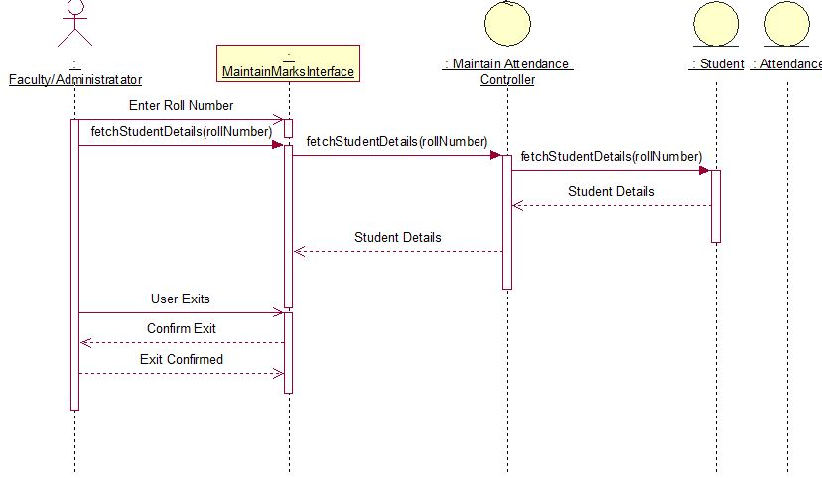

1. Upload Lecture/Course Material/Assignments
   1. Upload Assignments – Basic Flow

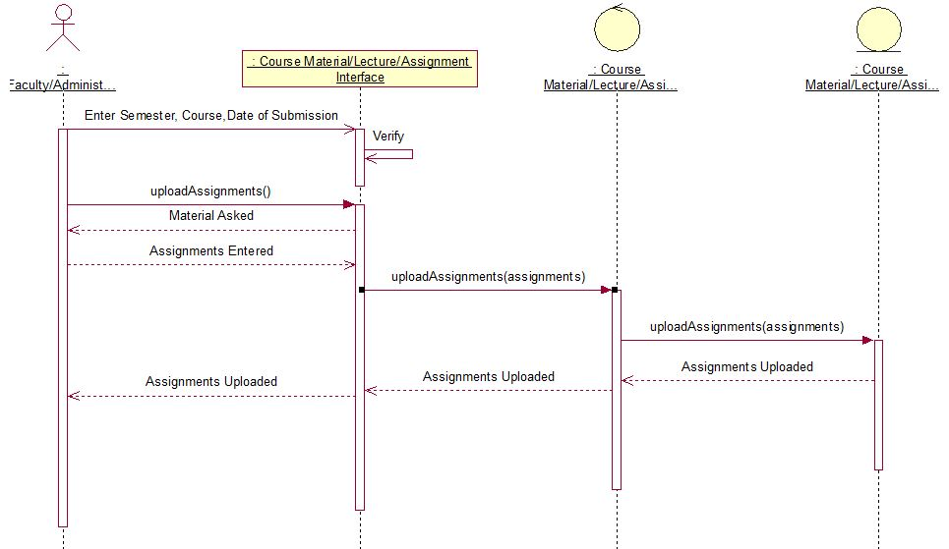

* 1. Upload Course Material – Basic Flow

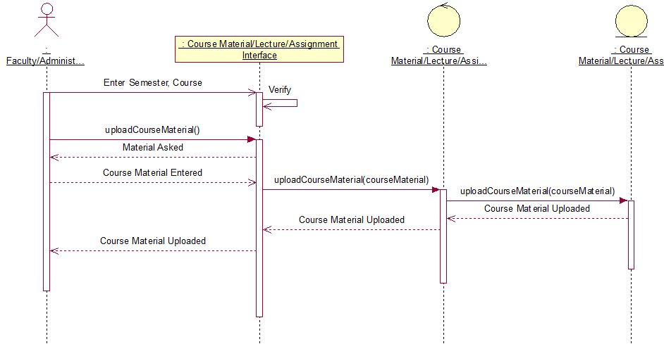

* 1. Upload Lectures – Basic Flow

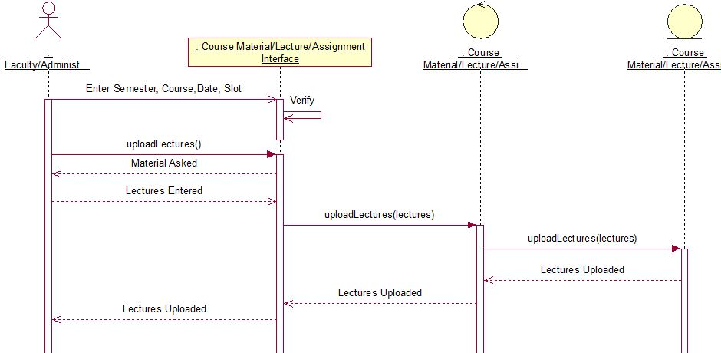

* 1. Upload Lecture/Course Material/Assignments – Alternate Flow – Invalid Details Entered

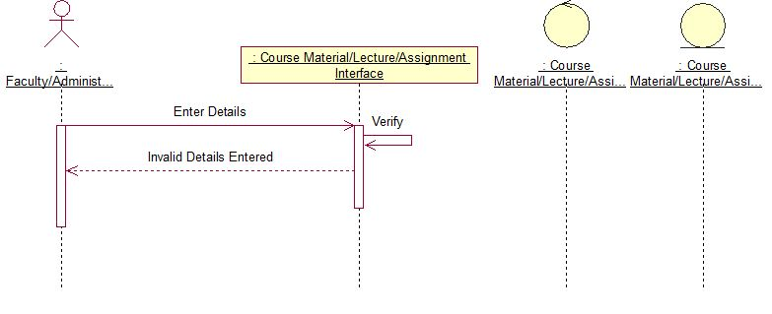

* 1. Upload Lecture – Alternate Flow – Lecture Already Exists

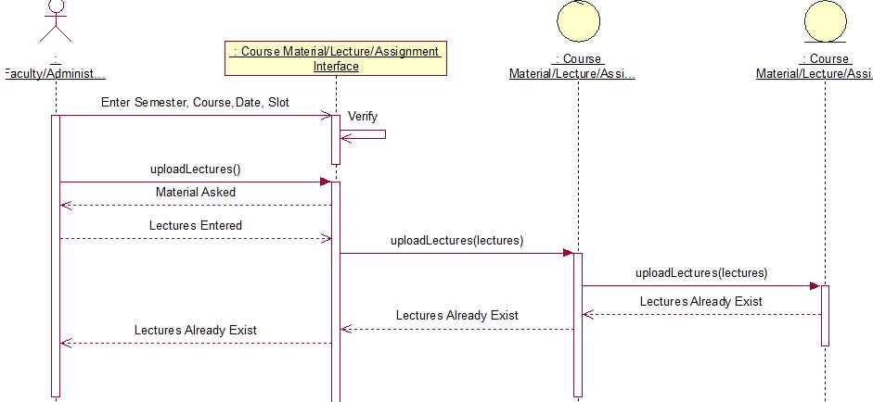

* 1. Upload Lecture/Course Material/Assignments – Alternate Flow – User Exit

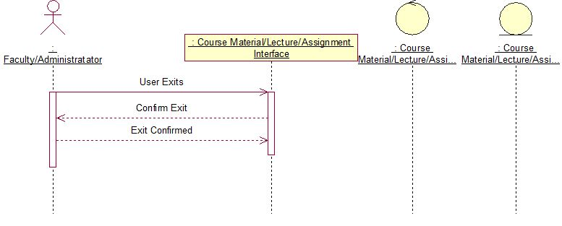

1. Register
   1. Basic Flow

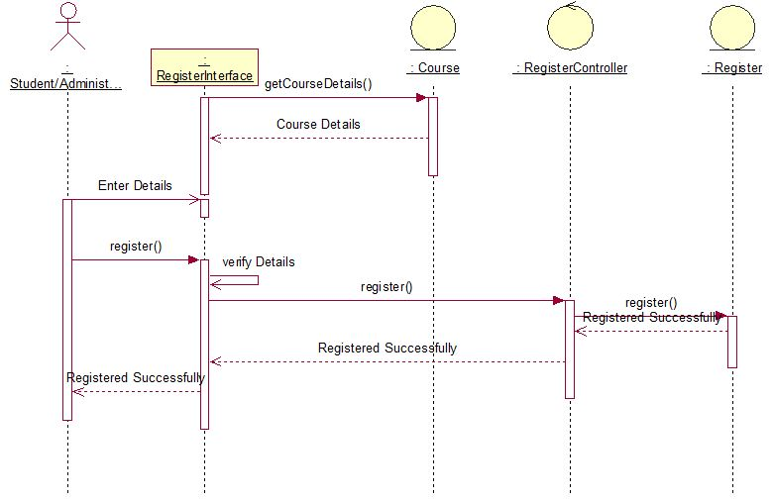

* 1. Register – Alternate Flow – Invalid Details Entered

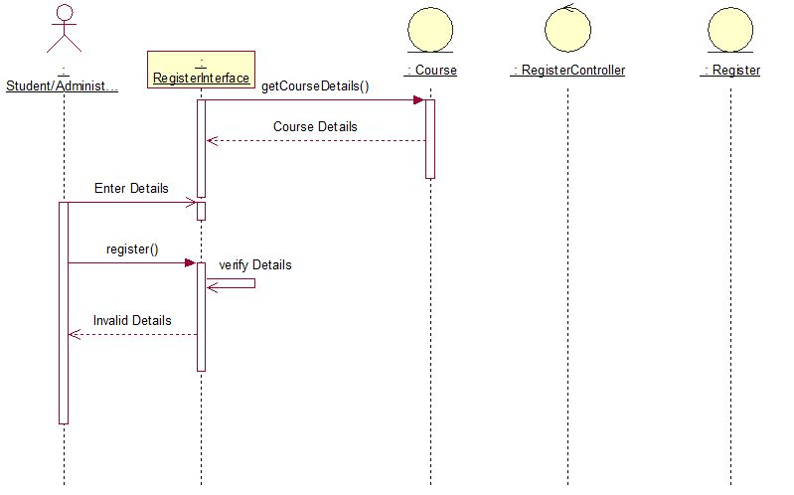

* 1. Register – Alternate Flow – Registration Cancelled

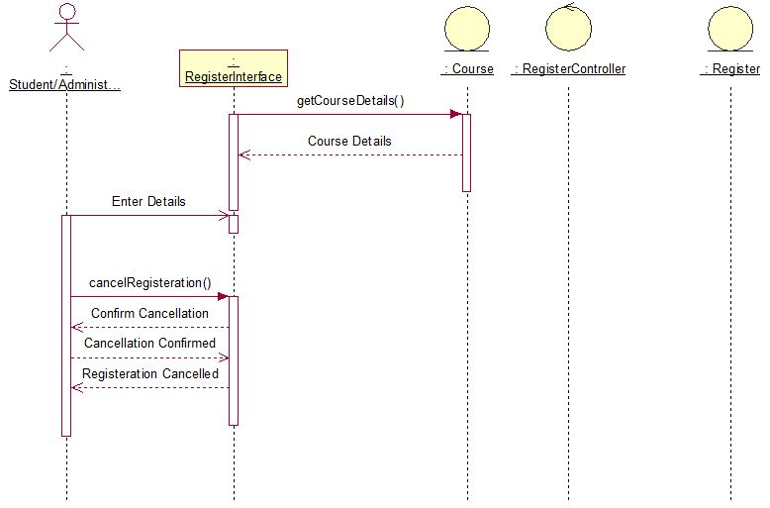

* 1. Register – Alternate Flow – User Exit

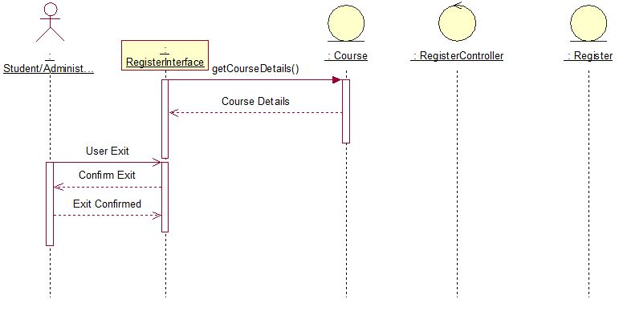

1. Download Lectures/Course Material/Assignments
   1. Download Assignment - Basic Flow

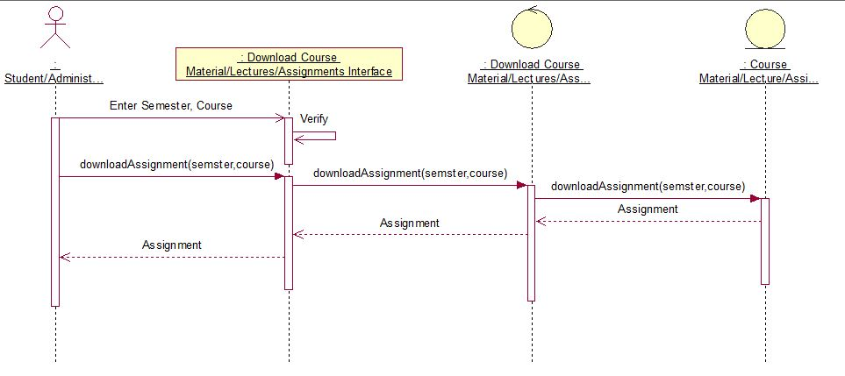

* 1. Download Course Material – Basic Flow

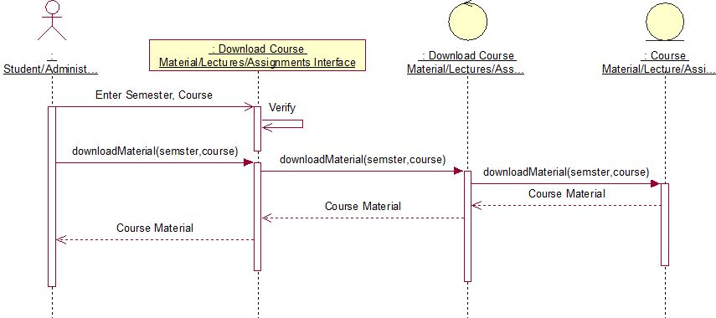

* 1. Download Lectures – Basic Flow

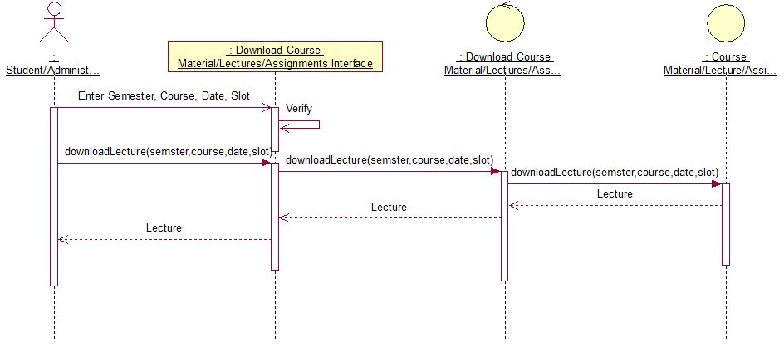

* 1. Download Course Material/Lecture/Assignments - Alternate Flow - Invalid Information Entered

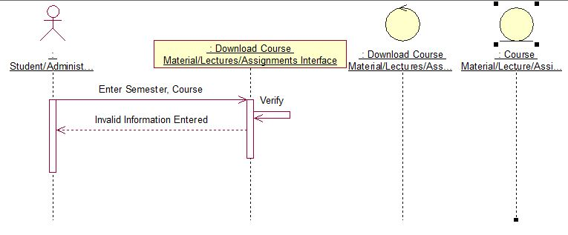

* 1. Download Course Material/Lecture/Assignments - Alternate Flow – Material Does Not Exist

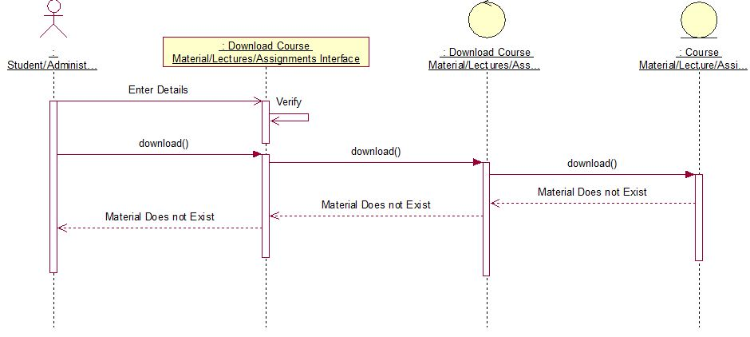

* 1. Download Course Material/Lecture/Assignments - Alternate Flow – User Exits

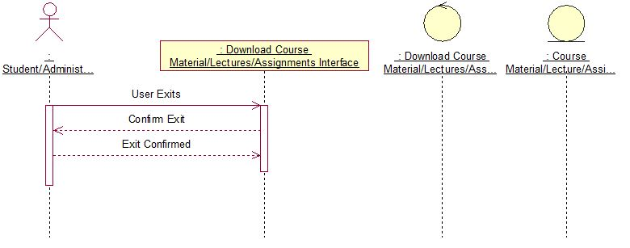

1. View Attendance
   1. Basic Flow

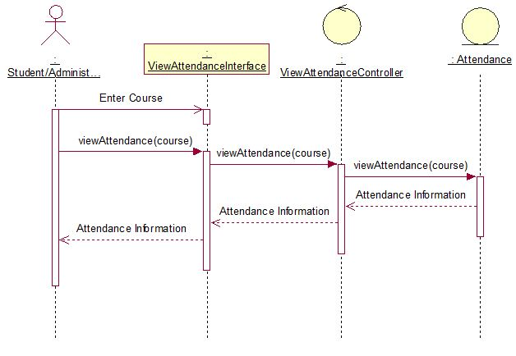

* 1. View Attendance - Alternate Flow - Print Attendance

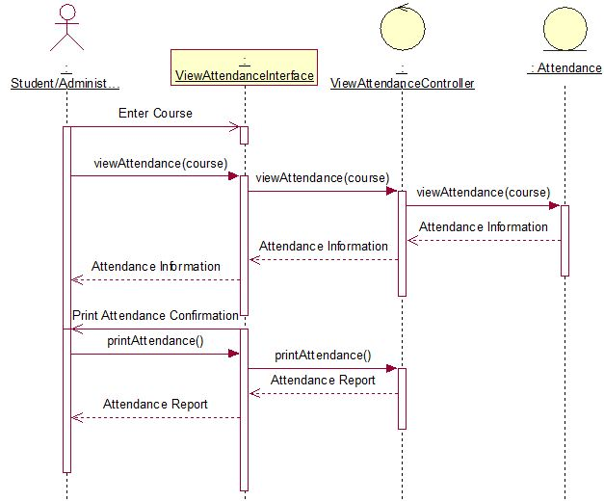

* 1. View Attendance - Alternate Flow - User Exit

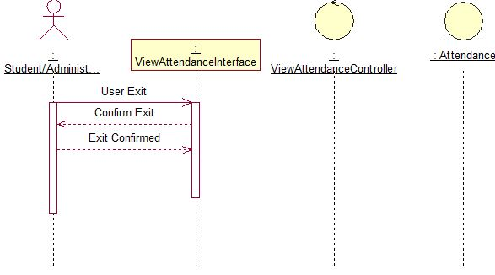

1. Forum
   1. Basic Flow

